Life Membership Form

1 | Name (first name middle name surname)
2 | Qualification (please attach short CV)
3 | Designation
4 | Date of Birth
5 | Sex
6 | Address
7 | Email
8 | Telephone/Mobile
9 | Details of Fees paid (reference, date)

Date:
Place:
Signature:
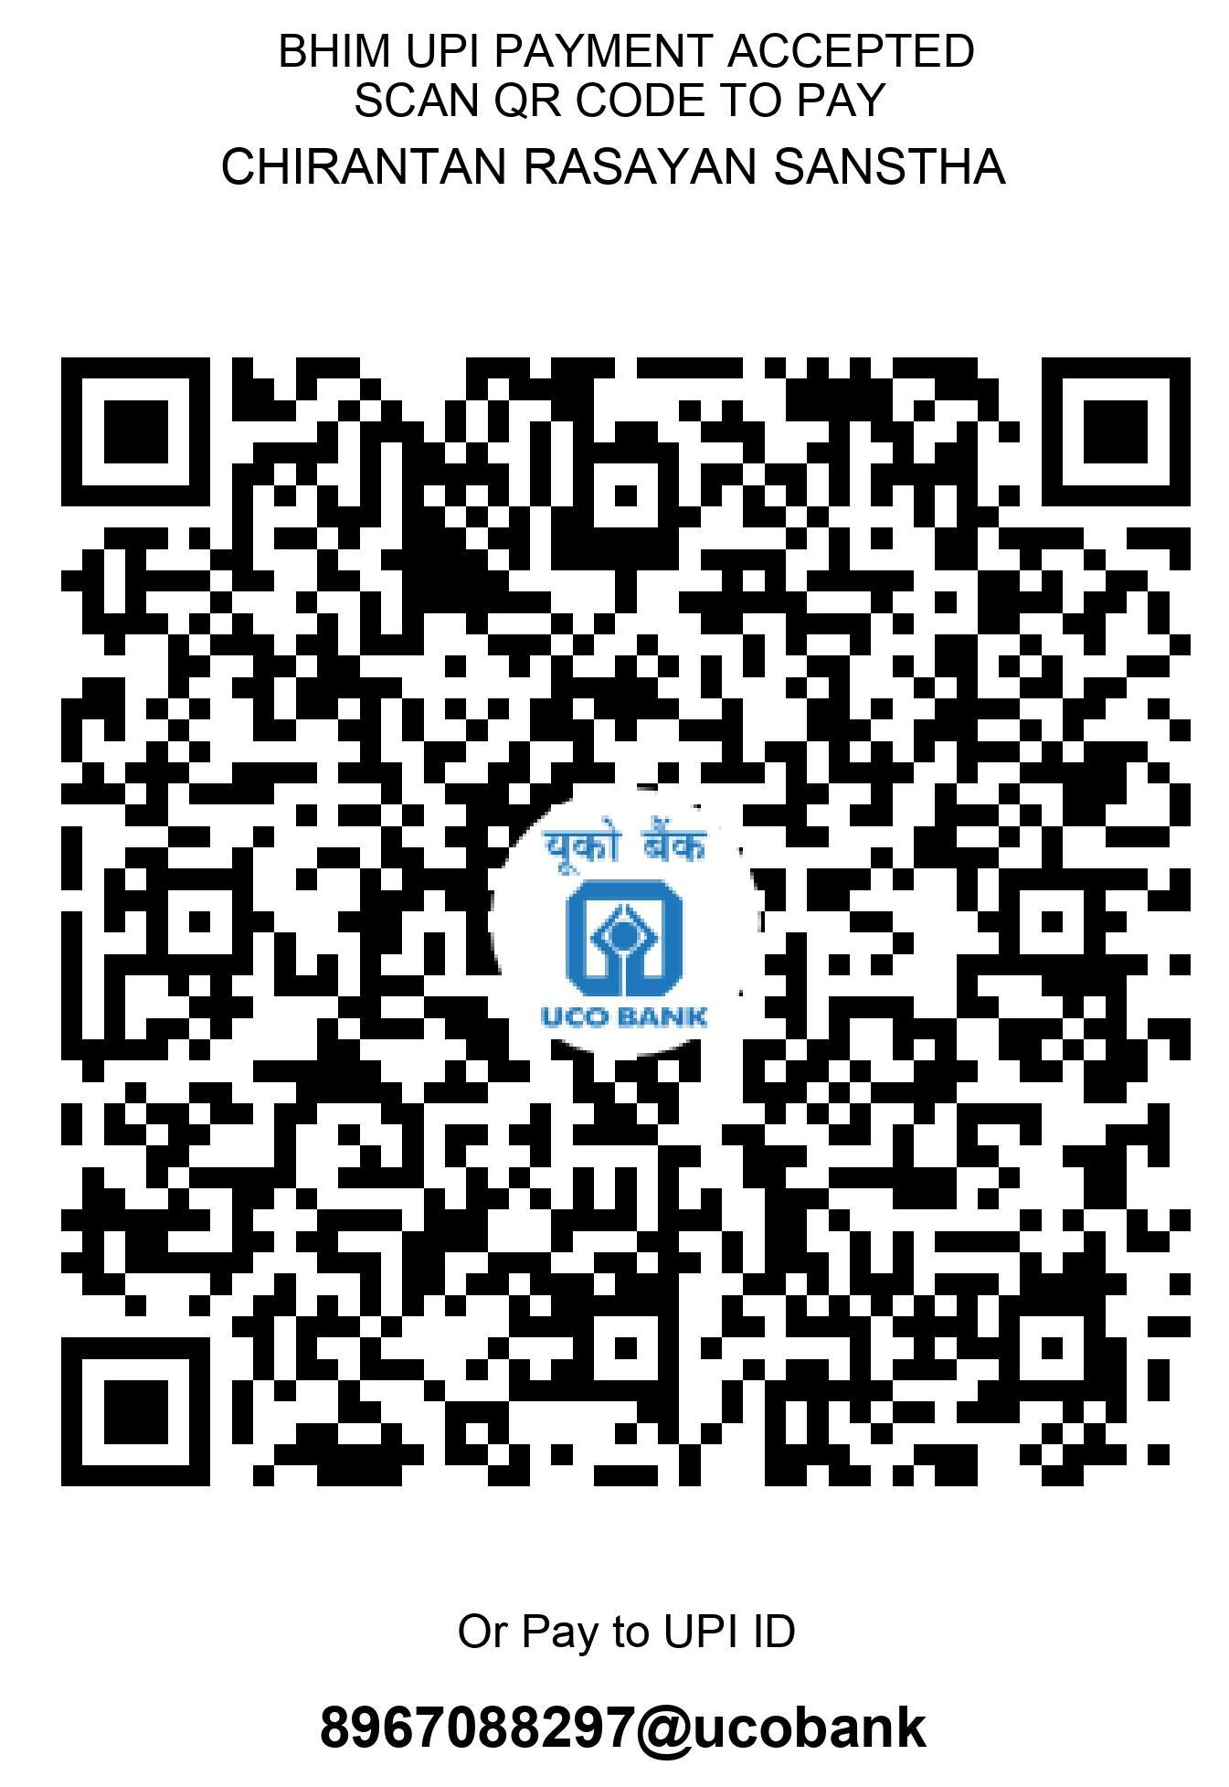

Life Membership Fees: 5000/-
Please send Life Membership fee in favour of
“Chirantan Rasayan Sanstha”
Account Details
Name of Account: Chirantan Rasayan Sanstha
Account number: 17480210000670
Name of Bank: UCO Bank
Branch: Vidyasagar University branch
Address: Vidyasagar University, Midnapore 721102, WB
IFSC Code: UCBA0001748

